CH4_CLOUDINARY IMAGE UPLOADING

in this video we will be focussing on adding and deleting products which includes connecting with cloudinary and add and delete update and getting recommeded products in cloudinary
1)setting up cloudinary
2)setting up environment
3)adding routes
4)adding controllers

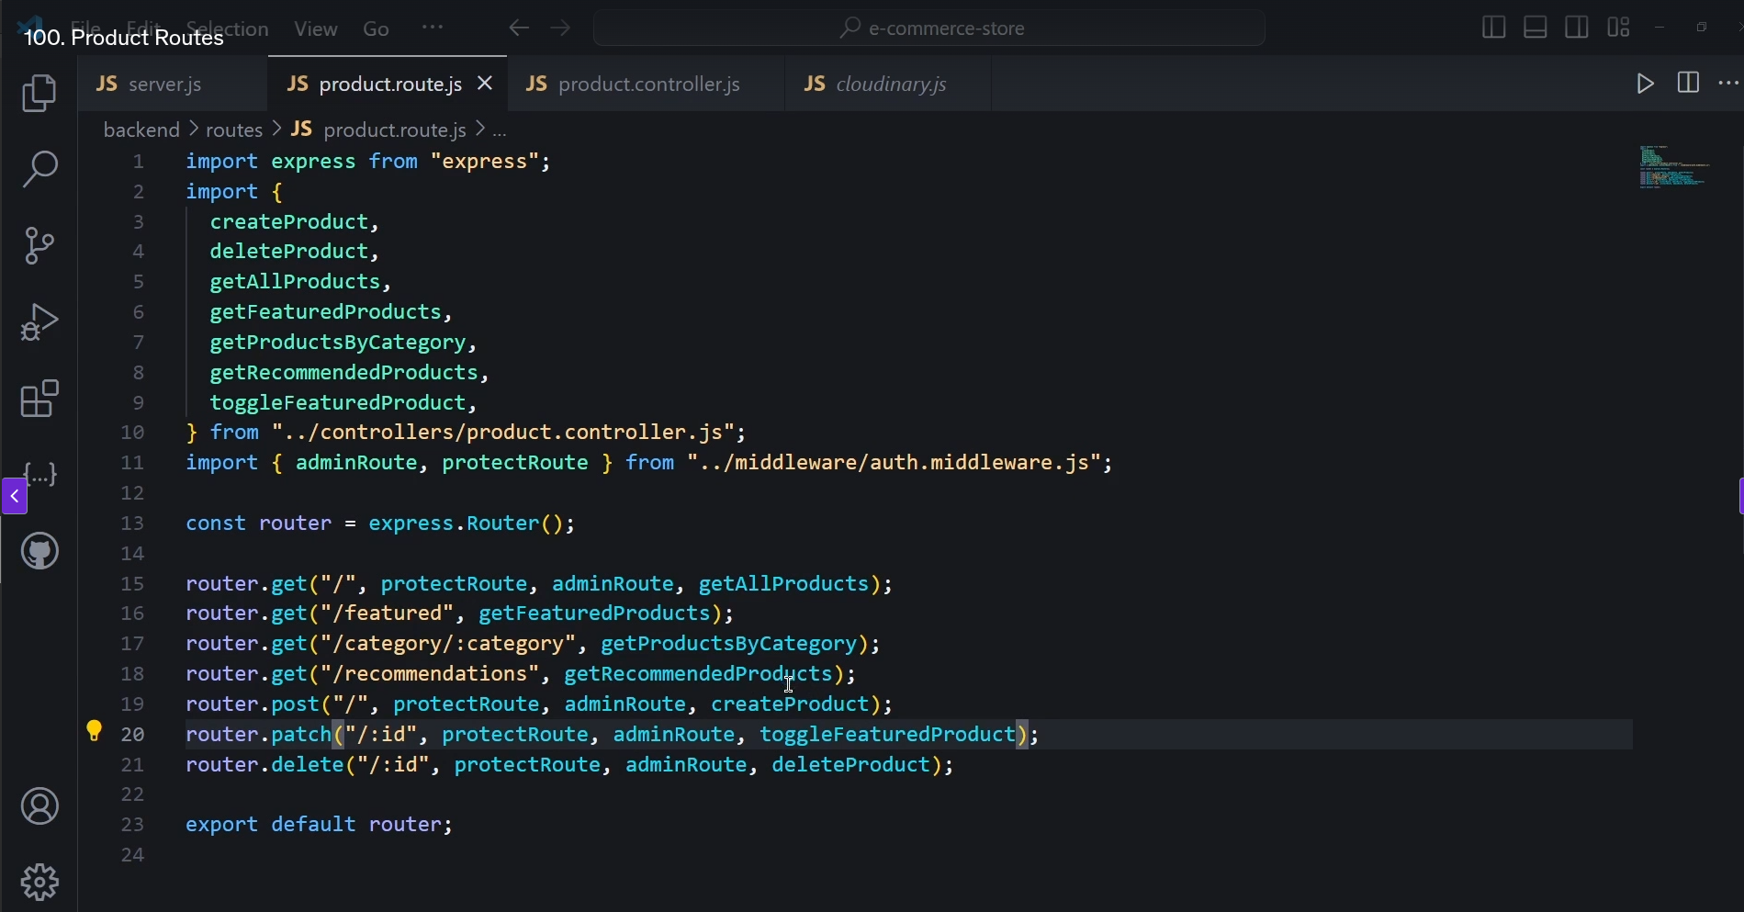

setting up cloudinary.js in lib forlder and updating .env file

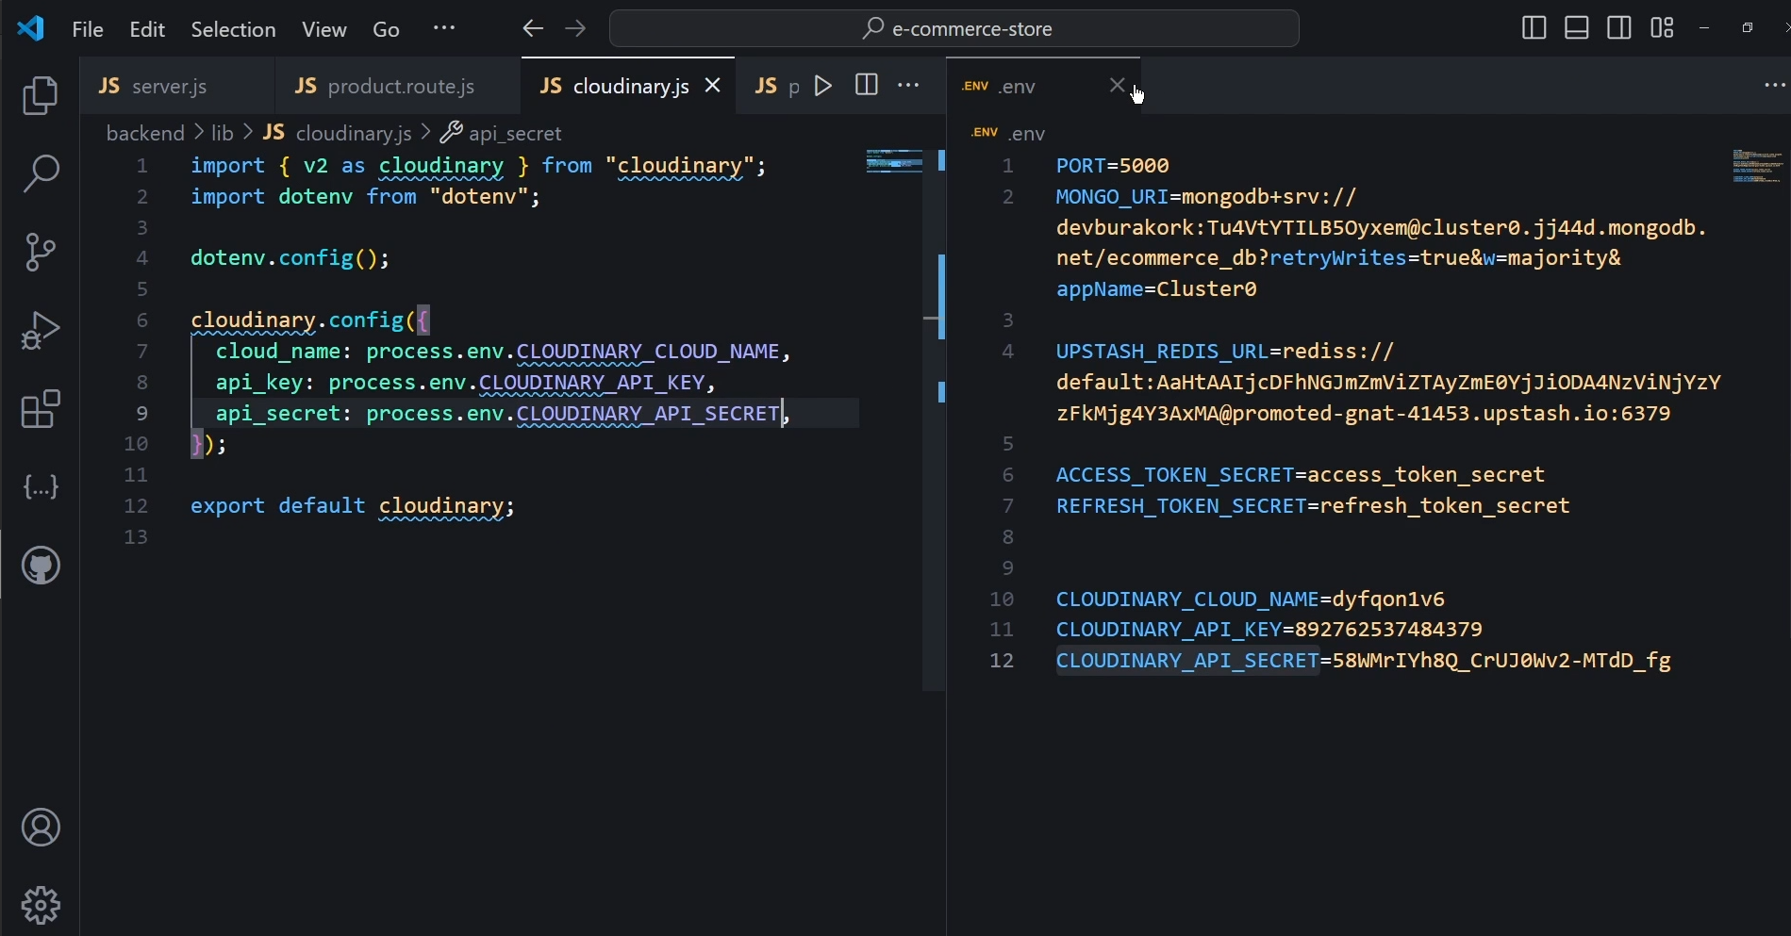

in the product controller now we are going to write controllers

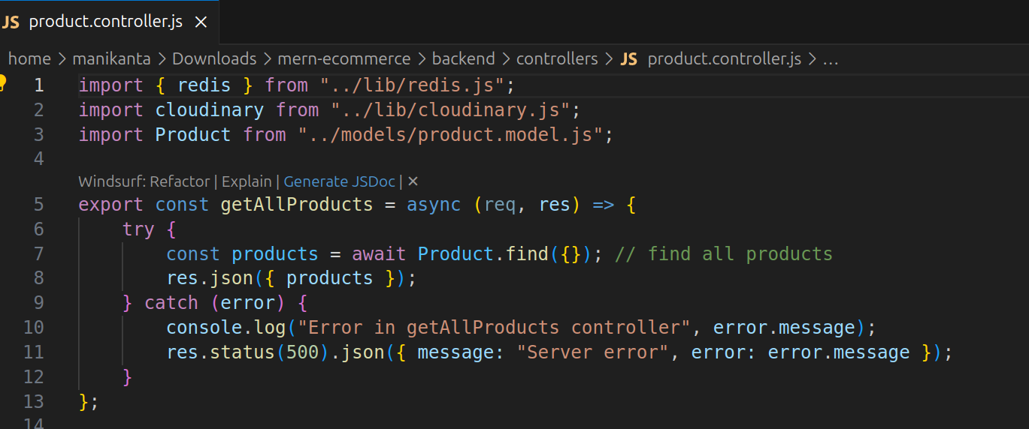
now for the featured rpoducts

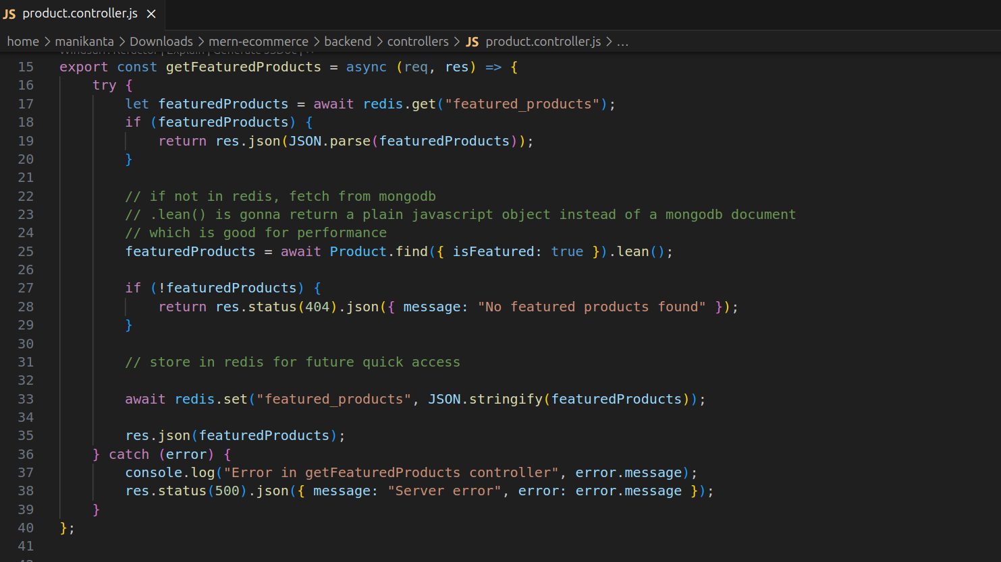

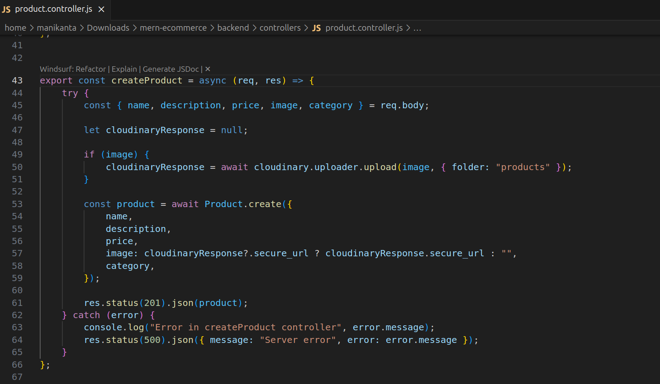
now to delete products

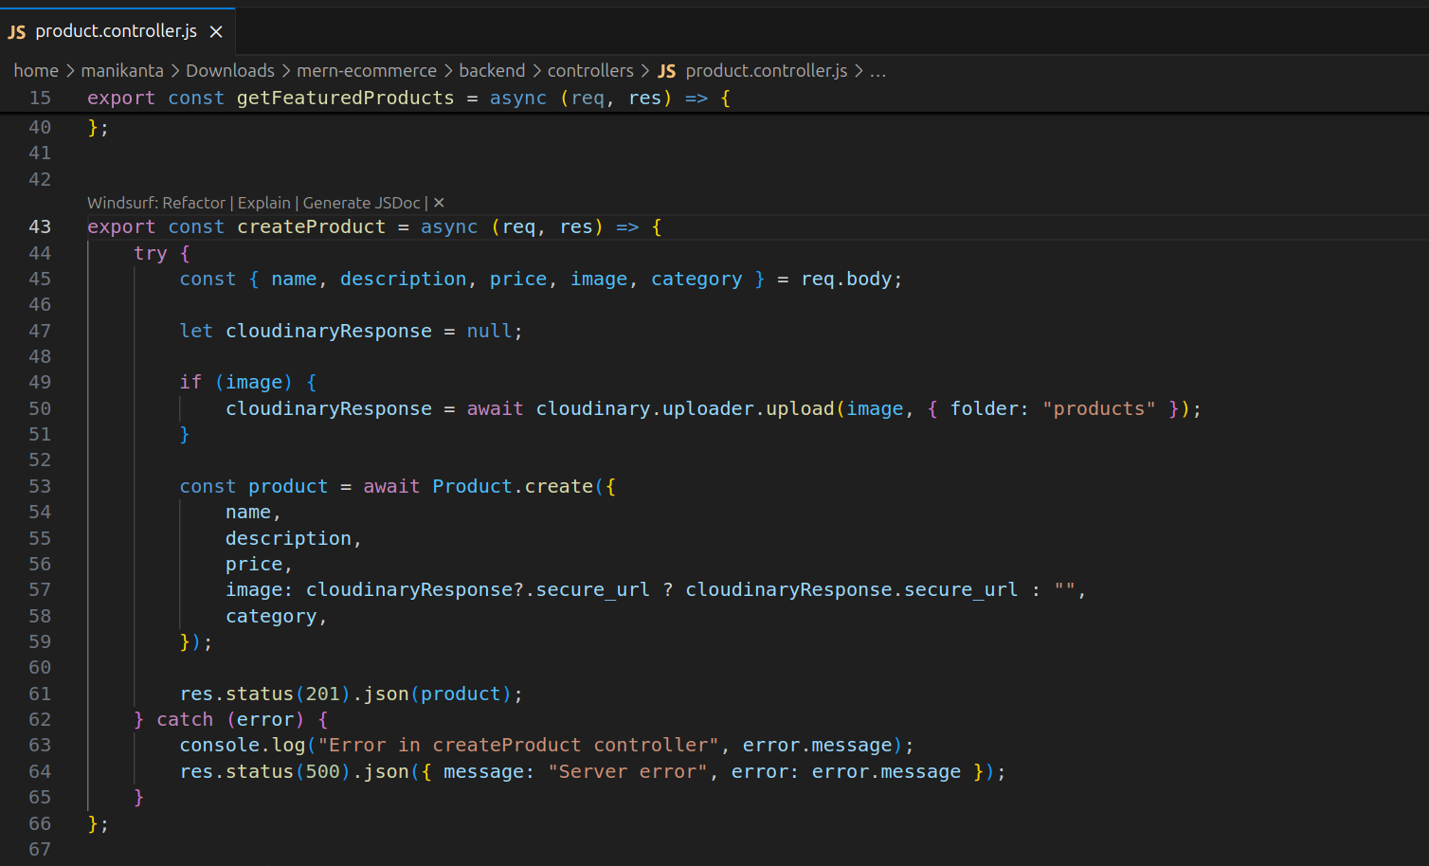
delete product

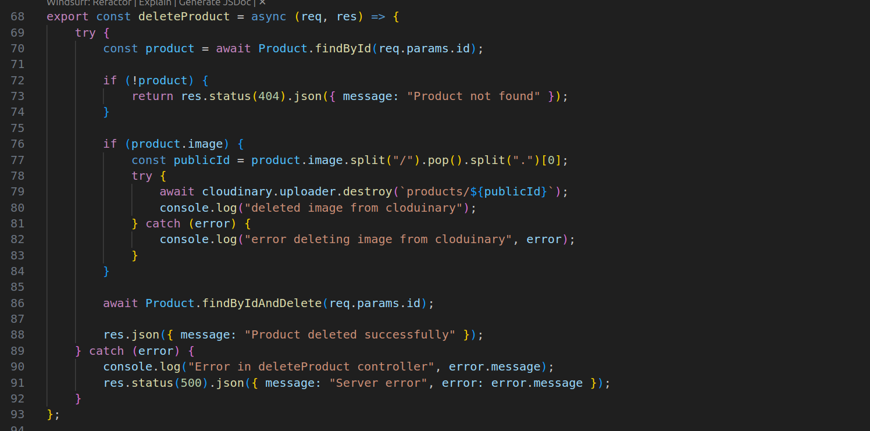
get recommeded products

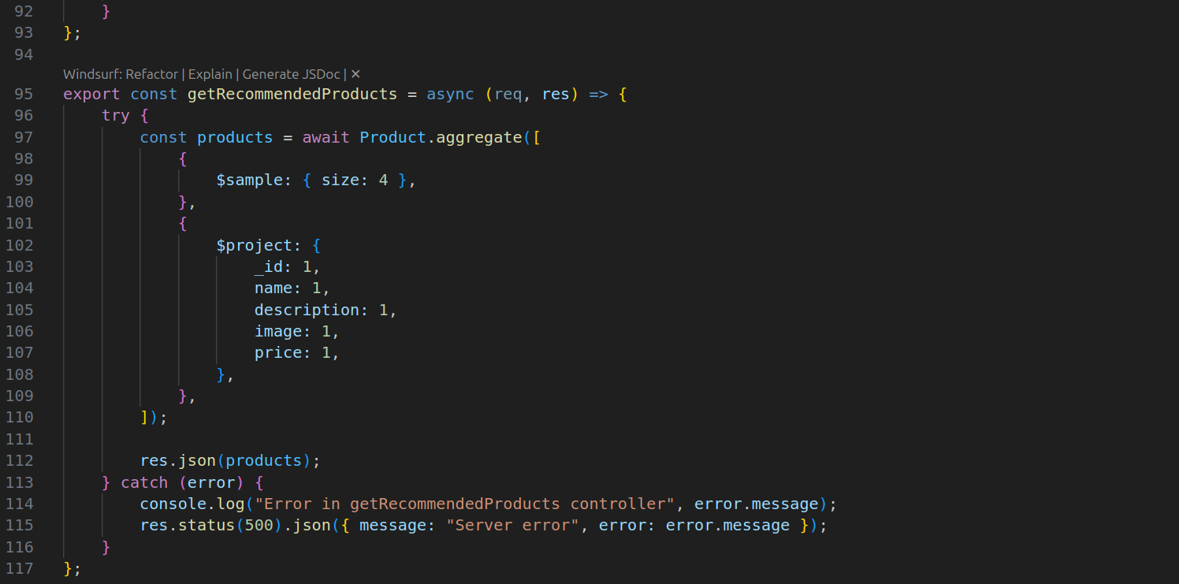
get products by cateogry

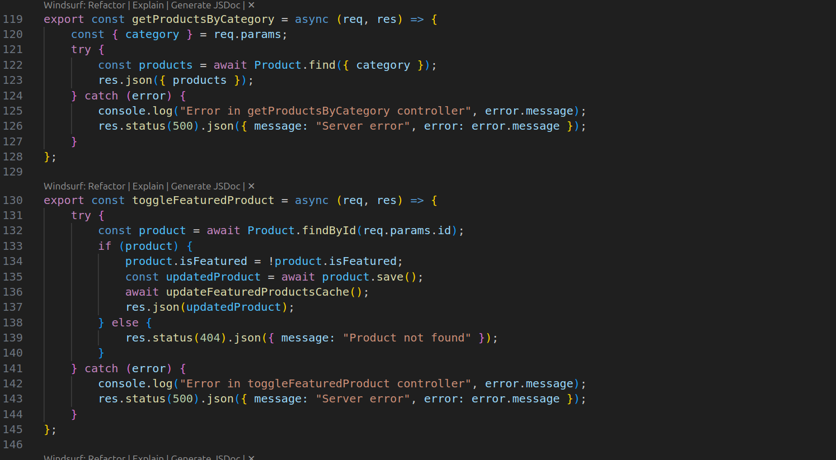
update featured product chache

